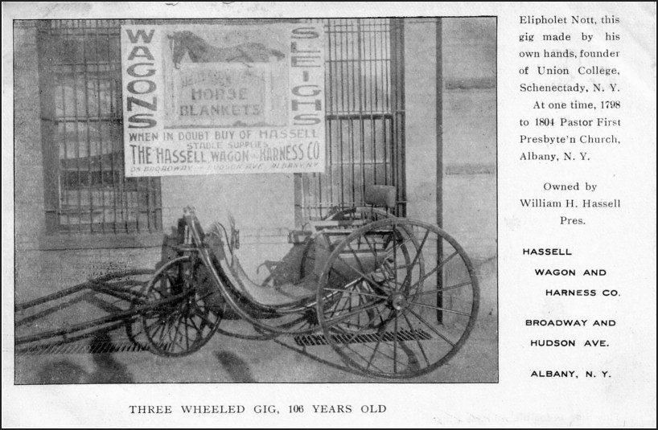
Copy of a postcard found at the New Lebanon , NY Flea Market, Sunday Oct 27, 2002
Eliphalet Nott
1773-1866, American educator, inventor, and clergyman, b. Ashford, Conn. In 1804, Nott became president of Union College, a post he held for 62 years; he initiated an extensive building program and introduced a scientific course as an alternative to the traditional classical curriculum. He published a number of pamphlets on slavery, temperance, and education and contributed to science by his experiments with heat. Nott was granted over 30 patents and was the inventor of the first anthracite coal base-burner stove.
(The Columbia Encyclopedia, Sixth Edition. 2001)

